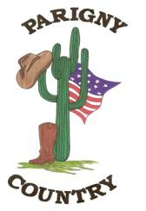

PLAYLIST BAL ANNUEL PARIGNY COUNTRY
SAMEDI 8 NOVEMBRE 2025
après midi de 17h30 à 18h55

Vero Country Walking Sylvain La Boussac/st brice
Agneaux
MODERN LINE COUNTRY /LINE

17H30 à 18H10 18H15 à 18 H 55
1 | Wings To Fly ( PC) D | 1 | K- Boy D
2 | Liebe Ist N | 2 | A Rattlesnake Kiss N
3 | Fantasia Fusion ( PC ) I | 3 | Straight Line I
4 | We can't Way D | 4 | Liar D/I
5 | Tide Is High ( PC) N | 5 | Double Devil D
6 | No Remorse ( PC ) I | 6 | Heel, Toe, Rodéo N
7 | Stop This Feeling ( PC ) D | 7 | Wildflowers/wild Horses D/I/P
8 | Dientes ( PC ) N | 8 | Better Than That D
9 | The Vibe I | 9 | Raised Like That N
10 | Cryo D | 10 | 'Til You Can't I
 | PAUSE |  | PAUSE

BON APPETIT..............

MERCI A VERO ET SYLVAIN

BAL PARIGNY 20H

